**Chapter 7: Transmission Media**

Table of Contents

7.1 Introduction 2

7.2 Guided Media 3

Twisted-Pair Cables 3

Coaxial Cables 6

Fibre-Optic Cables 8

7.2 Unguided Media 13

Propagation Methods 13

Bands 14

Radio Waves 15

Micro Waves 16

Infrared Waves 18

## 7.1 Introduction

A transmission medium is anything that can carry information from a source to a destination. It is located below the physical layer and is directly controlled by it.

In terms of data communication, transmission media take the form of free space, metallic cables or fibre-optic cables. The information being transmitted is generally a signal carrying data.

Transmission media can be divided into two categories:

1. Wired, or Guided
2. Wireless, or Unguided

A few forms of guided media include twisted-pair cables, coaxial cables and fibre-optic cables. A few forms of unguided media include radio waves, microwaves and infrared signals.

## 7.2 Guided Media

Guided media are transmission media that use a physical path to transmit data. As such, the signals being transmitted are directed and contained by the physical limitations of the media.

Twisted-pair and coaxial cables use copper conductors, and the signals they transmit are in the form of electric currents. Optical fibres on the other hand, transmit signals as light.

### Twisted-Pair Cables

A twisted-pair cable usually has two copper conductors, each with its own plastic insulation, twisted together. One of the wires carries signals, while the other acts as a ground reference. The receiver uses the difference between the two to interpret the signal.



#### Minimizing Noise

The wires are twisted to help minimize noise. If they were simply laid out parallelly, it is possible that one wire is affected by more noise than the other, due to being closer to the source of the noise. By twisting the cable, we ensure that one wire is closer to the source of the noise at one point, while the other is closer at another point. Thus, the overall effect of the noise is balanced out. Of course, the number of twists per unit length becomes relevant here.

#### Shielding

Around the pair of wires, there is generally a plastic covering. A cable that has this is called an unshielded twisted-pair (UTP) cable. Alternatively, there could also be a metal foil or mesh covering around the pair of wires, and a plastic covering above that. The metal prevents noise from getting in, but also makes the cable heavier and more expensive. Such cables are called shielded twisted-pair (STP) cables. They are not generally used.

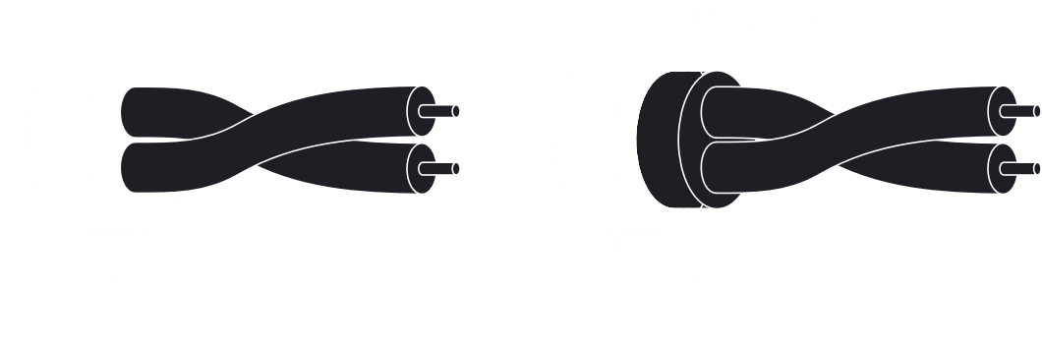

#### Categories

The Electronics Industries Association (EIA) has developed standards that classify UTP cables into 7 categories, from lowest to highest.

|  |  |  |  |
| --- | --- | --- | --- |
| **Category** | **Specification** | **Data Rate ($Mbps$)** | **Use** |
| 1 | UTP used in telephones. | $$<0.1$$ | Telephones |
| 2 | UTP originally used in T-lines. | $$2$$ | T-1 Lines |
| 3 | Improved CAT-2 used in LANs. | $$10$$ | LANs |
| 4 | Improved CAT-3 used in Token Ring networks. | $$20$$ | LANs |
| 5 | Cable wire, normally 24 AWG with a jacket and outside sheathe. | $$100$$ | LANs |
| 5E | An extension to category 5 that has extra features to minimize noise. | $$125$$ | LANs |
| 6 | A new category with matched components coming from the same manufacturer. The cable must be tested at a $200 Mbps$ data rate. | $$200$$ | LANs |
| 7 | Sometimes called shielded screen twisted-pair (SSTP), each pair is individually wrapped in a helical metallic foil, followed by a metallic foil shield in addition to the outside sheath. The shield decreases the effect of crosstalk and increases the data rate. | $$600$$ | LANs |

#### Connectors

On either side of a UTP cable, there is an RJ45 connector. RJ stands for registered jack. The RJ45 is a keyed connector, meaning it can only be connected in one direction.

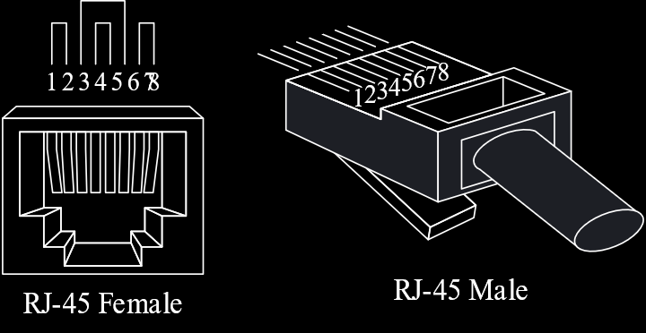

#### Performance

In terms of performance, twisted-pair cables can pass a wide range of frequencies. However, at higher frequencies, especially above $100kHz$, the attenuation increases. The thinner the wire, the higher the attenuation.

#### Applications

Twisted-pair cables are used in telephone lines and LANs. The lines that connect subscribers to the central telephone office as well as the high-data-rate DSL lines make use of UTP cables.

### Coaxial Cables

Coaxial cables carry signals of higher frequency ranges than twisted-pair cables. A coaxial cable has a central core conductor enclosed by an insulating sheath with a metal foil or mesh around it. The metal wrapping acts as the second conductor and also as a shield against noise. Around this, there is another insulator and finally a plastic covering.



#### Standards

Coaxial cables are categorized by their Radio Government (RG) ratings. Each eating specifies physical characteristics, like wire gauge of the conductor, thickness and type of insulator, construction of the metal shield and size and type of the plastic cover.

|  |  |  |
| --- | --- | --- |
| **Category** | **Impedance** | **Use** |
| RG-59 | $$75Ω$$ | Cable TV |
| RG-58 | $$50Ω$$ | Thin Ethernet |
| RG-11 | $$50Ω$$ | Thick Ethernet |

#### Connectors

Coaxial cables commonly use Bayonet Neill-Concelman (BNC) connectors. BNC connectors are used to connect the cable to a device. Connections can also be branched out using T-shaped BNC-T connectors. BNC terminators are used at the end of cables.



#### Performance

Although coaxial cables have a higher bandwidth than twisted-pair cables, they also have greater attenuation. This means coaxial cables need more frequent repeaters.

#### Applications

Coaxial cables were widely used in TV networks, telephone networks and ethernet LANs due to their high data rate. Nowadays however, they have been replaced in the first two cases by fibre-optic.

### Fibre-Optic Cables

Fibre-optic cables are made of glass or plastic and use the property of reflection to transmit signals in the form of light. The glass or plastic core is surrounded by less dense glass or plastic cladding, and the difference in density causes light to reflect off the cladding and remain in the core.

#### Propagation Modes

There are two modes of propagating light through optical channels, single mode and multimode.

In multimode, multiple beams of light move through the core in different paths. There are two subcategories of multimode, step-index and graded-index.

In step-index, the core has the same density throughout, so the light beams travel in straight lines. When they reach the cladding however, there is a sudden change in density. The light beams are reflected, but the sudden change causes some distortion.

In graded-index, the density of the core decreases from the centre to the edges. Thus, the change at the cladding is less sudden, so there is less distortion.

In single mode, the light beams are more focused. The core is step-index and is so small and less dense, that the beams reflect off the edges almost horizontally. The beams all arrive together, which decreases distortion.



#### Fibre Sizes

Optical fibres are defined by the ratio of core diameter / cladding diameter, both in $μm$.

|  |  |
| --- | --- |
| **Type** | **Mode** |
| $$50/125$$ | Multimode, graded |
| $$62.5/125$$ | Multimode, graded |
| $$100/125$$ | Multimode, graded |
| $$7/125$$ | Single mode |

#### Cable Composition

Around the fibre itself, there is a layer of plastic, then a layer of Kevlar, and finally a PVC or Teflon outer layer.

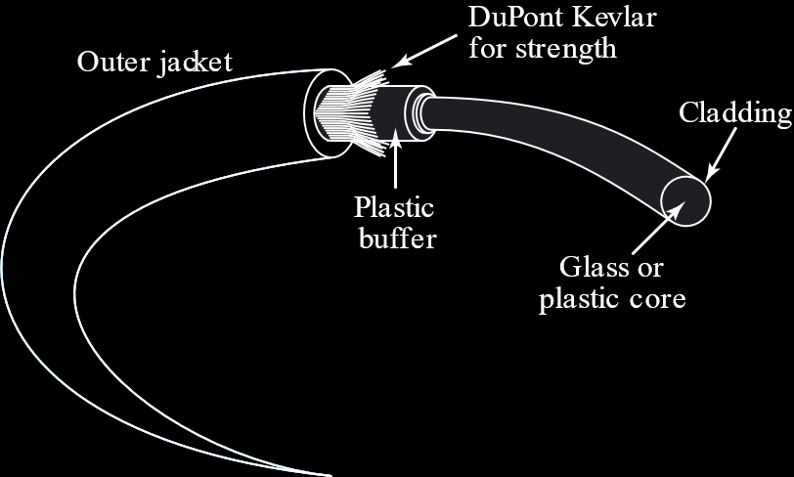

#### Connectors

There are three types of connectors for fibre-optic cables:

1. Subscriber channel connectors, that use a push/pull locking system and are used with TVs.
2. Straight-tip connectors, that use a more reliable bayonet locking system and are used with networking devices.
3. MT-RJ, which is the same size as RJ-45.

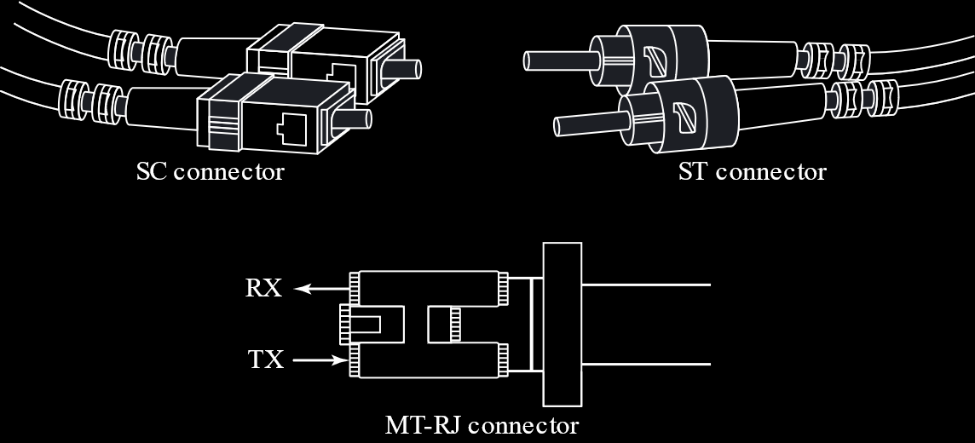

#### Performance

Fibre-optic has far better performance than twisted-pair or coaxial cables, as there is much less attenuation.

#### Applications

The large bandwidth of fibre-optic cables makes it cost effective for backbone networks. Some cable companies and LANs use fibre-optic cables.

#### Advantages

* Higher bandwidth
* Less signal attenuation
* Immunity to electromagnetic interference
* Resistance to corrosive materials
* Light weight
* Immunity to tapping

#### Disadvantages

* Expensive
* Unidirectional
* Require expertise to install and maintain

## 7.2 Unguided Media

Unguided media transport electromagnetic waves without any physical conductor. Thus, such communication is more commonly known as wireless communication. Signals are broadcast through free space and are thus available to anyone with a device capable of receiving them. A part of the electromagnetic spectrum, from $3kHz$ to $900THz$, is used.

### Propagation Methods

Unguided signals travel in several ways:

* Ground Propagation
* Sky Propagation
* Line-of-Sight Propagation

In ground propagation, low-frequency radio waves transmitted by an antenna emanate in all directions. They travel through the lowest portion of the atmosphere and follow the curvature of the Earth. The stronger the signal, the further it travels.

In sky propagation, high-frequency radio waves are reflected off the ionosphere. This consumes less power.

In line-of sight propagation, high-frequency signals are transmitted straight from antenna to antenna. The antennas have to be directional, facing each other, and either tall enough or close enough to not be affected by the curvature of the Earth. Line-of-sight propagation is tricky because radio waves cannot be focused.

### Bands

Radio waves and micro waves are divided into ranges, called bands, each of which are regulated by government authorities.

|  |  |  |  |
| --- | --- | --- | --- |
| **Band** | **Range** | **Propagation** | **Application** |
| Very Low Frequency (VLF) | $3$- $30 kHz$ | Ground | Long-range radio navigation |
| Low Frequency (LF) | $30$- $300 kHz$ | Ground | Radio beacons and navigational locators |
| Middle Frequency (MF) | $300 kHz$- $3 MHz$ | Sky | AM radio |
| High Frequency (HF) | $3$- $30 MHz$ | Sky | Citizens Band (CB), ships, aircrafts |
| Very High Frequency (VHF) | $30$- $300 MHz$ | Sky and Line-of-Sight | VHF TV, FM radio |
| Ultra-High Frequency (UHF) | $300 MHz$- $3 GHz$ | Line-of-Sight | UHF TV, cellular phones, paging, satellites |
| Superhigh Frequency (SF) | $3$- $30 GHz$ | Line-of-Sight | Satellite |
| Extremely High Frequency (EHF) | $30$- $300 GHz$ | Line-of-Sight | Radar, satellite |

Wireless transmission can be divided into three groups:

1. Radio Waves
2. Micro-Waves
3. Infrared Waves

### Radio Waves

The frequency at which a wave stops being a radio wave and becomes a microwave is a bit blurry, but generally, the waves in the range $3 kHz$- $1 GHz$ are called radio waves, while those from $1 GHz$- $300 GHz$ are called microwaves. Behaviour is a better classification though.

Radio waves are omnidirectional, meaning they propagate in all directions from the point of transmission. Thus, antennas do not need to be aligned. However, this same property can cause problems. If another signal with the same frequency is nearby, there will be interference.

#### Transmission

Radio waves can travel long distances, especially those that work in sky mode. This makes them perfect for long distance transmission, like in AM radios. They also penetrate walls, especially at low frequencies. This can be both good and bad, since it means broadcasts can reach inside buildings, but also that they cannot be contained.

#### Bandwidth

The radio band is relatively narrow. It can be divided into sub-bands that are also narrow, which means data rates are low. The entire band is regulated and using any part requires permission from the relevant authorities.

#### Antennas

Radio wave antennas are omnidirectional, meaning the signal is sent in every direction. There can be many types of antennas based on the wavelength, strength and purpose of transmission.

#### Applications

The omnidirectional characteristics of radio waves make them perfect for multicasting, with one sender and many receivers. They are used in AM and FM radios, television broadcasting, cordless phones, pagers, etc.

### Micro Waves

Microwaves have frequencies between $1 GHz$ and $300 GHz$. They are unidirectional, so they can be narrowly focused, and the antennas need to be aligned. This property also means that micro waves will not interfere with other signals. The antennas also have to be within line-of-sight. If they are far apart, they need to be tall to avoid obstacles in between and also the curvature of the Earth.

Microwaves that have very high frequencies cannot penetrate walls, which is bad if receivers are inside.

#### Bandwidth

Microwaves have a large band, so large sub-bands can be used, which allows for high data rates. Parts of the band are regulated.

#### Antennas

Microwaves need unidirectional antennas. These can be of two types:

1. Parabolic Dish Antennas
2. Horn Antennas



In parabolic dish antennas, all signals parallel to the line-of-sight get reflected off the curve and meet at the focus. Thus, more of the signal is recovered than would have been possible with a single point. Outgoing signals are aimed at the dish, which reflects them out as parallel lines.

In a horn antenna, outgoing signals go up the step and are reflected out by the curved part as parallel lines. Incoming signals follow the same path in the reverse direction.

#### Applications

The unidirectional nature of microwaves makes them good for unicast communication. They are used in cellular phones, satellite networks and wireless LANs.

### Infrared Waves

Infrared waves have frequencies between $300 GHz$ and $400 THz$. At such high frequencies, they are good in the sense that they do not cause interference, since they cannot penetrate walls. This same property makes them useless for long-distance communication though. Additionally, they cannot be used outside, since the Sun’s rays contain infrared waves and would cause interference.

#### Applications

The huge bandwidth of infrared waves makes them good for high data rates. They are used for line-of-sight communication between keyboards, mice, PCs and printers.